**EXP NO: 02**

**Aim:**

To Create a simple cloud software application for Property Buying & Rental process (In Chennai city) using any Cloud Service Provider to demonstrate SaaS include the necessary fields such as Buy, Rent, commercial, Rental Agreement , Rental Agreement, Area, place, Range, property value etc.

**Implementation:**

1.Go to Zoho.com and login/signup

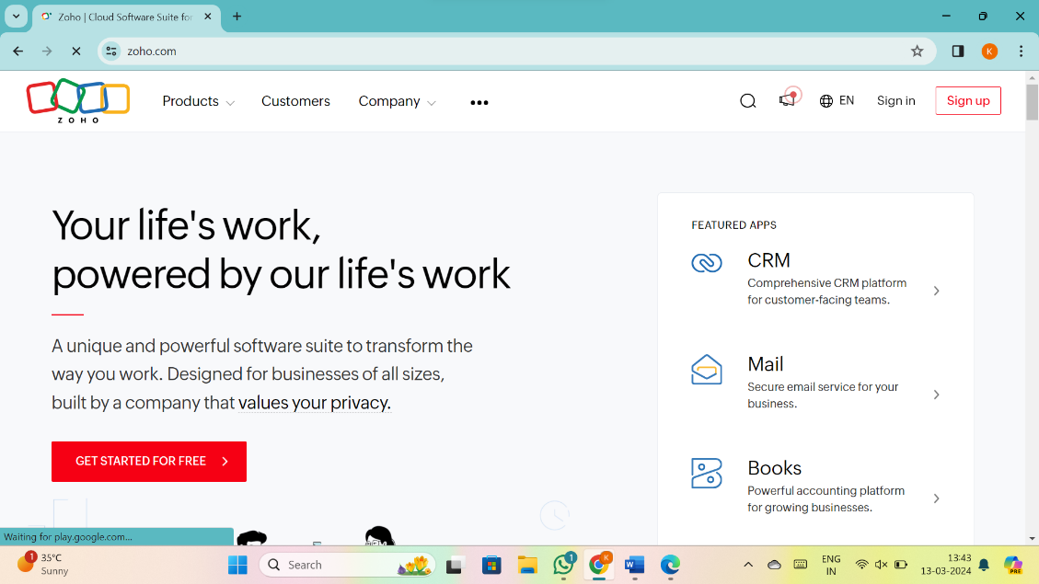

2.Go to Creator

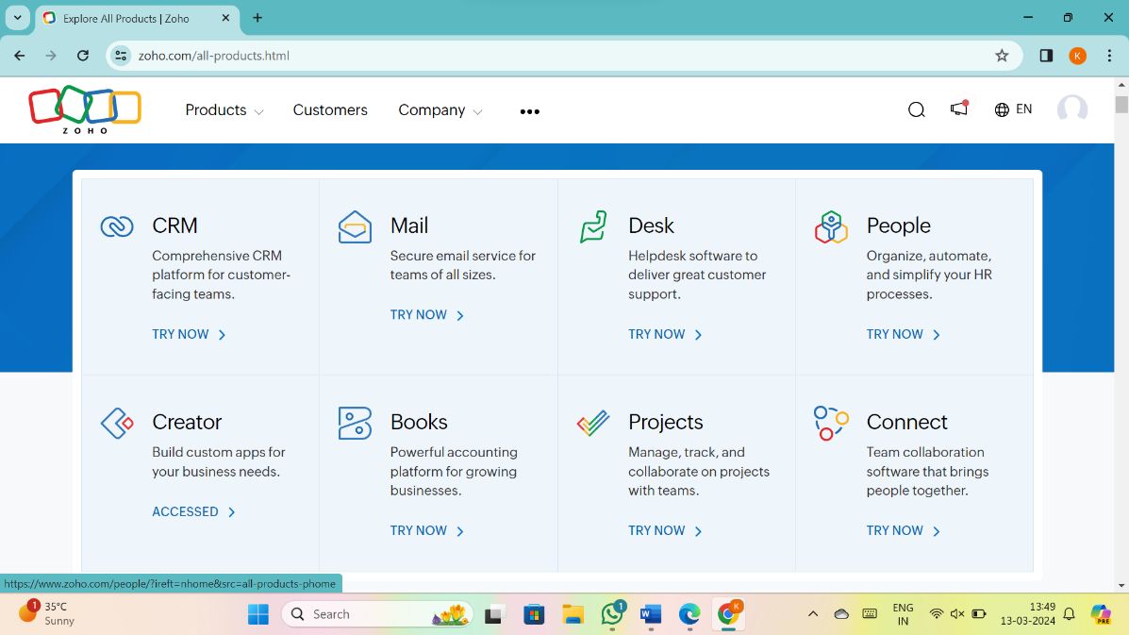

3. CREATE NEW APPLICATION

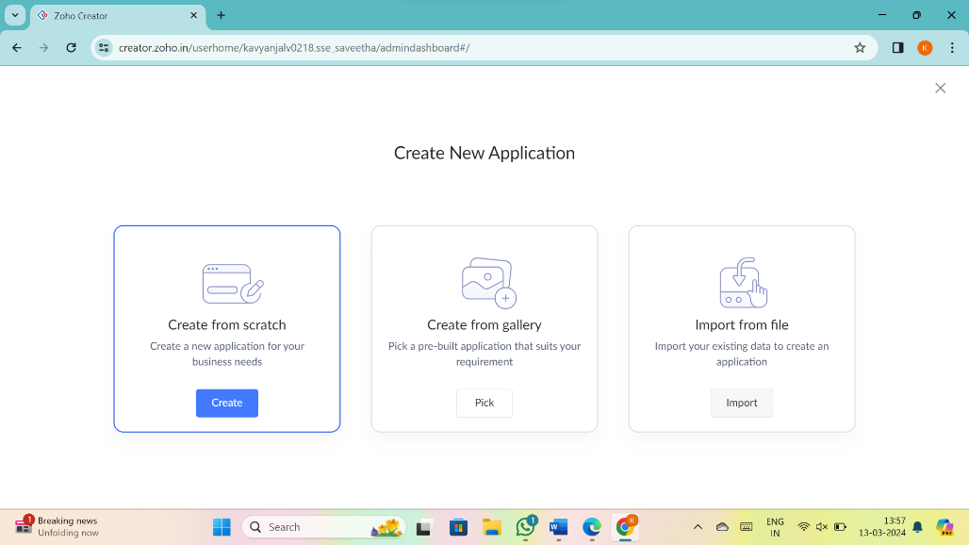

4.Give Application Name

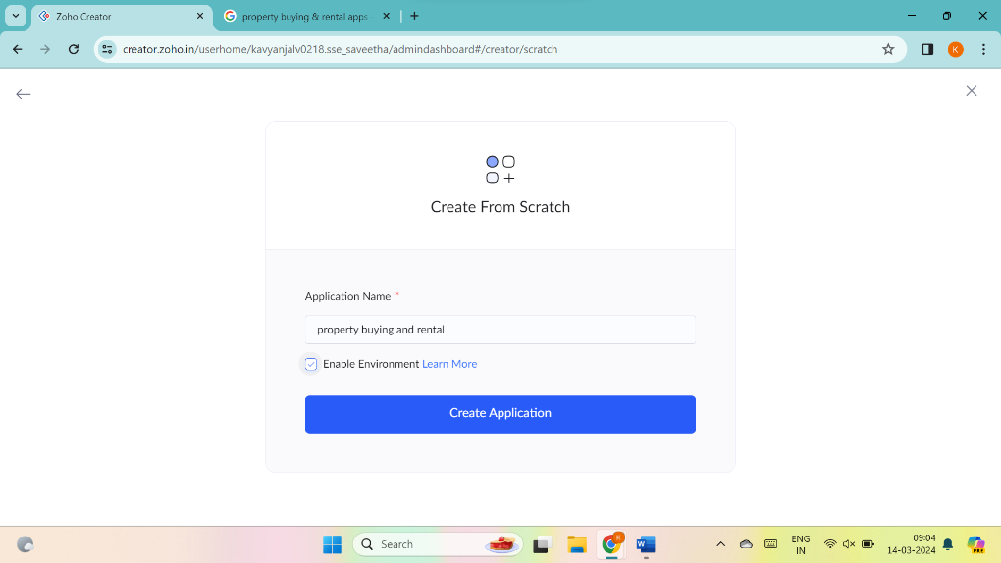

5.Create New Form

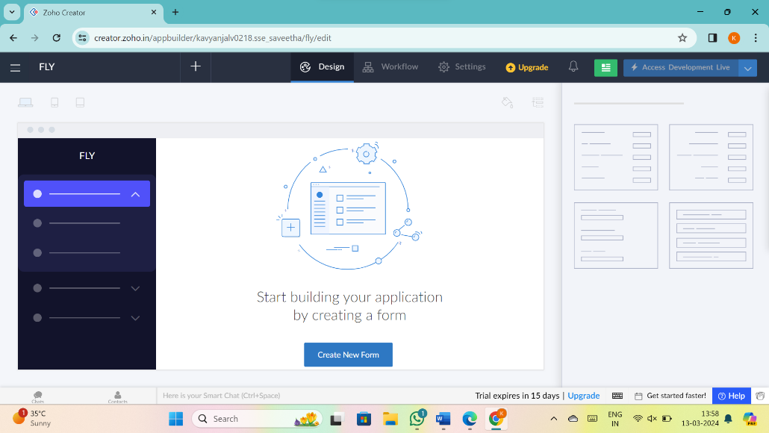

6.Select Form and give name

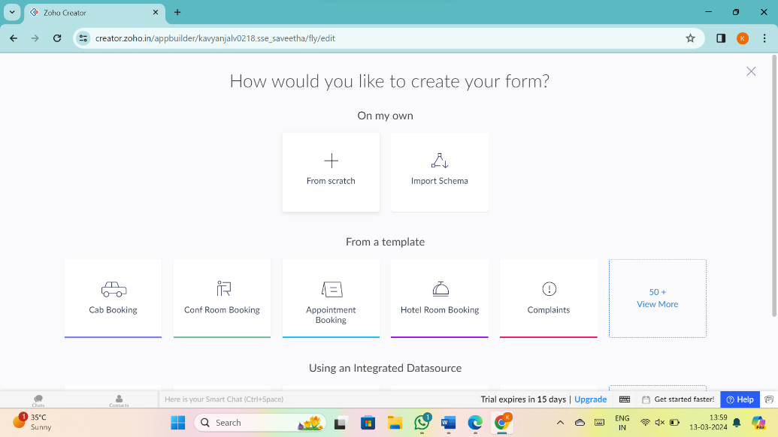

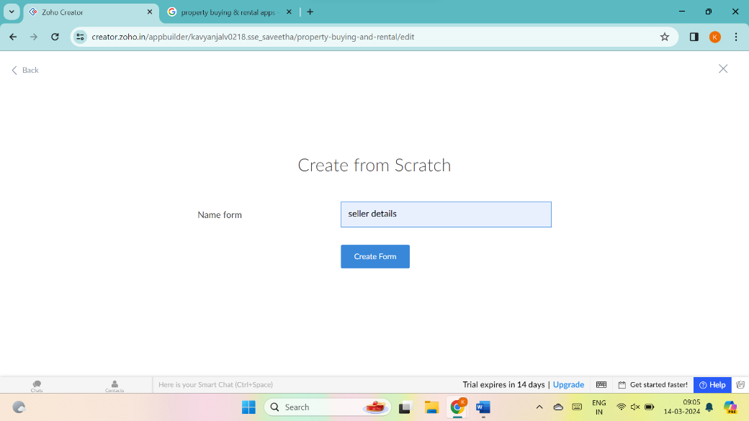

7.Drag necessary fields

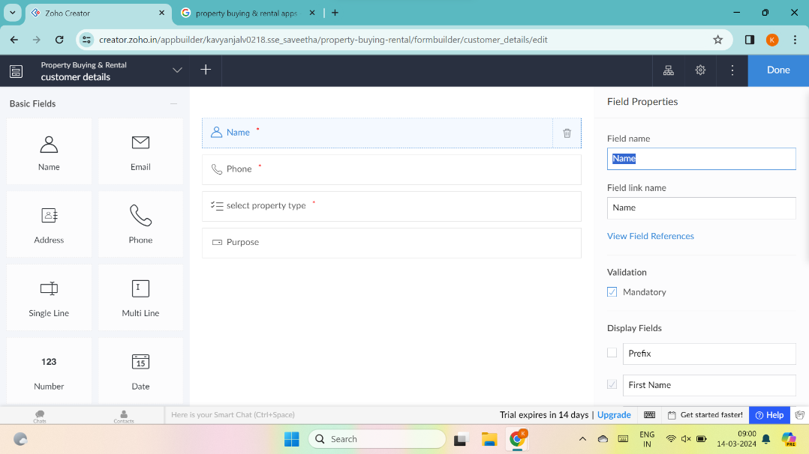

8.create new forms if necessary

8.create new forms if necessary

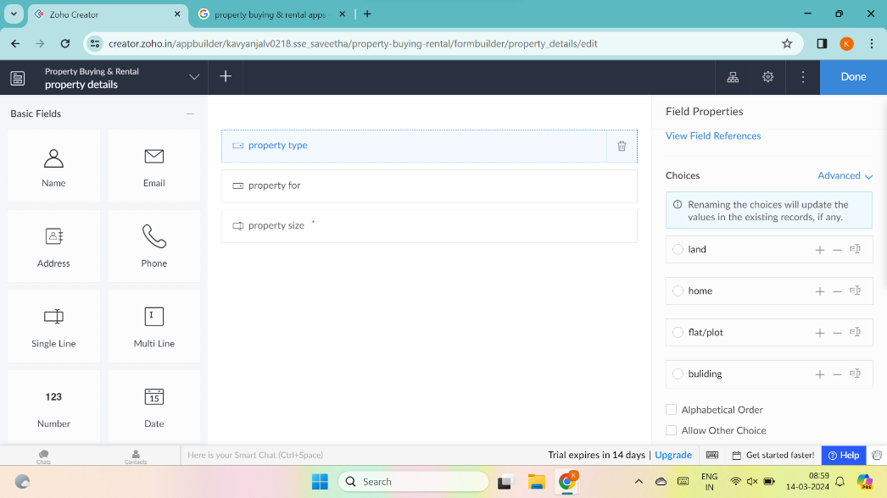

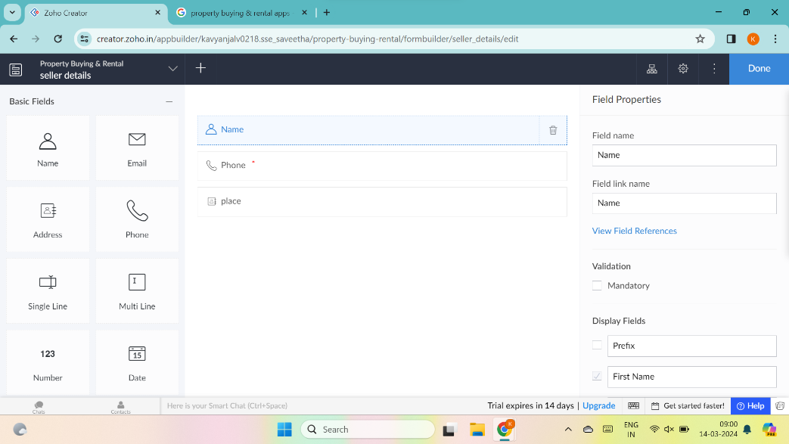

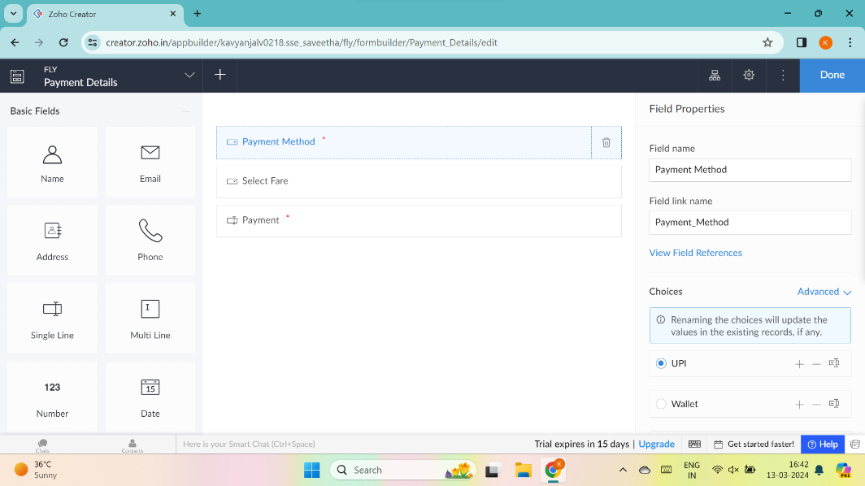

9.The software has been created

